LAB Logbook
Lab 12
calculation of your parameters
your code of using EarlyStopping() and ModelCheckpoint() functions
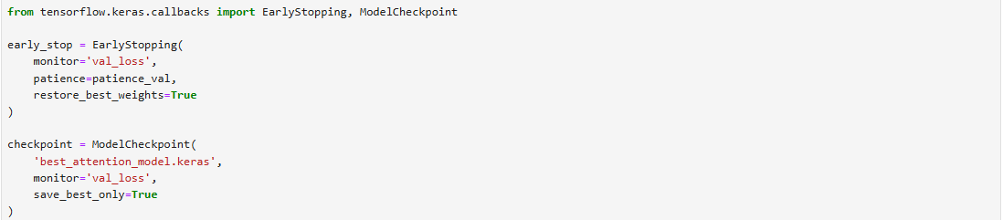
your code and training result using model.fit()
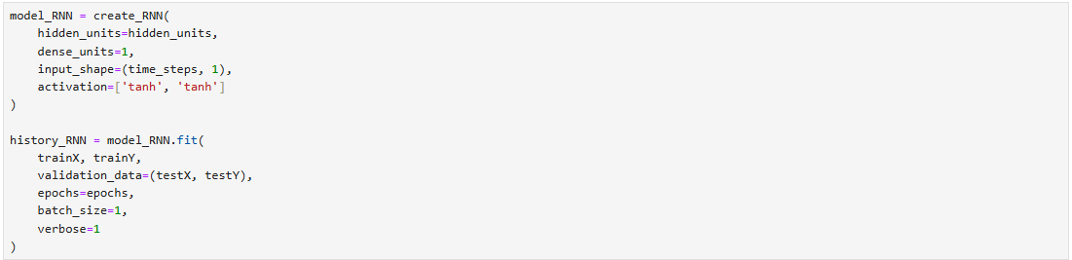
received loss for train and test datasets
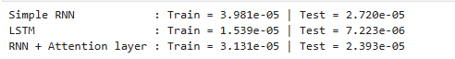

Loss (MSE) graph for the 3 models together during the training process
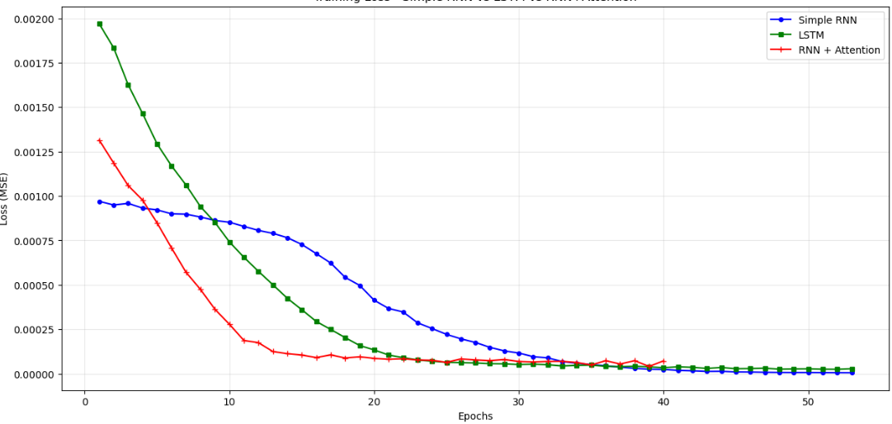
performance histogram for train and test loss (MSE) of the 3 models together
